
Subject: Programming with Java
ASSIGNMENT No : 20
TITLE: Develop a Java application to establish connectivity with a database and perform INSERT, UPDATE, and DELETE operations.

Name: Avdhoot Mohite Class: CSE A2
PRN: 25070122056 Batch:25-29

Problem Statement
Develop a Java application to establish connectivity with a database and perform INSERT, UPDATE, and DELETE operations.

Learning Objectives
- To understand database connectivity using JDBC.
- To perform database modification operations using INSERT, UPDATE, and DELETE.
- To use PreparedStatement for executing parameterized SQL queries.
- To manage database records efficiently using Java.

Theory
JDBC (Java Database Connectivity) allows Java applications to connect with relational databases and perform various database operations. Database modification operations are performed using SQL Data Manipulation Language (DML) statements such as INSERT, UPDATE, and DELETE.
The INSERT statement is used to add new records to a database table. The UPDATE statement modifies existing records, while the DELETE statement removes unwanted records from a table.
In Java, these operations can be performed using the Statement or PreparedStatement interface. PreparedStatement is generally preferred because it supports parameterized queries, improves performance, and provides protection against SQL injection.
The basic steps involved in JDBC operations are establishing a database connection, creating a statement, executing the SQL query, processing the result, and closing the database resources. Proper transaction management can also be used to ensure that database modifications are performed safely and consistently.
JDBC-based database operations are widely used in applications such as banking systems, hospital management systems, employee management systems, and student information systems.

Exercise 1
Problem Statement
Create a Java application to manage employee records using CRUD operations.
CODE:
import java.sql.*;

public class assignment20a {
public static void main(String[] args) {

String url = "jdbc:mysql://localhost:3306/college";
String username = "root";
String password = "Avdrocks@0504";

try {
Class.forName("com.mysql.cj.jdbc.Driver");

Connection con = DriverManager.getConnection(
url, username, password
);

// INSERT
String insertQuery =
"INSERT INTO employee VALUES (?, ?, ?, ?)";

PreparedStatement ps = con.prepareStatement(insertQuery);

ps.setInt(1, 101);
ps.setString(2, "Rahul");
ps.setString(3, "IT");
ps.setDouble(4, 45000);

ps.executeUpdate();
System.out.println("Employee record inserted successfully.");

// UPDATE
String updateQuery =
"UPDATE employee SET salary = ? WHERE emp_id = ?";

ps = con.prepareStatement(updateQuery);

ps.setDouble(1, 50000);
ps.setInt(2, 101);

ps.executeUpdate();
System.out.println("Employee record updated successfully.");

// DELETE
String deleteQuery =
"DELETE FROM employee WHERE emp_id = ?";

ps = con.prepareStatement(deleteQuery);

ps.setInt(1, 101);

ps.executeUpdate();
System.out.println("Employee record deleted successfully.");

ps.close();
con.close();

} catch (Exception e) {
System.out.println("Error: " + e.getMessage());
}
}
}

OUTPUT:
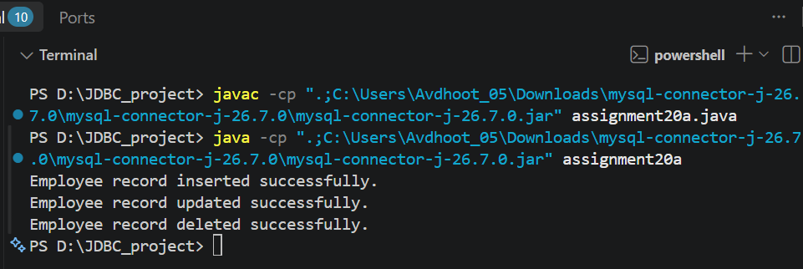

Exercise 2
Problem Statement
Create a Java application to manage student records using CRUD operations. Perform Create, Read, Update, and Delete operations on student details such as roll number, name, course, and marks using a database.
CODE:
import java.sql.*;

public class assignment20b {
public static void main(String[] args) {

String url = "jdbc:mysql://localhost:3306/college";
String username = "root";
String password = "Avdrocks@0504";

try {
Class.forName("com.mysql.cj.jdbc.Driver");

Connection con = DriverManager.getConnection(
url, username, password
);

// CREATE - INSERT
String insertQuery =
"INSERT INTO student_crud VALUES (?, ?, ?, ?)";

PreparedStatement ps = con.prepareStatement(insertQuery);

ps.setInt(1, 1);
ps.setString(2, "Avdhoot");
ps.setString(3, "CSE");
ps.setInt(4, 85);

ps.executeUpdate();
System.out.println("Student record inserted successfully.");

// READ - SELECT
String selectQuery = "SELECT * FROM student_crud";

ps = con.prepareStatement(selectQuery);
ResultSet rs = ps.executeQuery();

System.out.println("\nStudent Records:");
System.out.println("--------------------------------");

while (rs.next()) {
System.out.println("Roll No: " + rs.getInt("rollno"));
System.out.println("Name: " + rs.getString("name"));
System.out.println("Course: " + rs.getString("course"));
System.out.println("Marks: " + rs.getInt("marks"));
System.out.println("--------------------------------");
}

rs.close();

// UPDATE
String updateQuery =
"UPDATE student_crud SET marks = ? WHERE rollno = ?";

ps = con.prepareStatement(updateQuery);

ps.setInt(1, 90);
ps.setInt(2, 1);

ps.executeUpdate();
System.out.println("Student record updated successfully.");

// DELETE
String deleteQuery =
"DELETE FROM student_crud WHERE rollno = ?";

ps = con.prepareStatement(deleteQuery);

ps.setInt(1, 1);

ps.executeUpdate();
System.out.println("Student record deleted successfully.");

ps.close();
con.close();

} catch (Exception e) {
System.out.println("Error: " + e.getMessage());
}
}
}

OUTPUT:
